CSCE5350: Fundamentals of Databases

# Final Report

## Project Name: E Learning Platform

### Group Details:

|  |  |
| --- | --- |
| Team Member | Roll Number |
| Nikhil Chowdary Kollipati | 11801655 |
| Shivani Jannaikode | 11800623 |
| Divya Sai Sri Murugudu | 11705488 |
| Vinay Kumar Reddy Esireddy | 11818698 |

### Project Management

|  |  |
| --- | --- |
| Action Items | Task Owner |
| Selecting tables and ER Diagram | Shivani Jannaikode, Divya Sai Sri Murugudu |
| Registration, Login, Profile Management (Frontend and Backend) | Vinay Kumar Reddy Esireddy |
| Course Creation, management, browsing and enrolment (Front end & Backend) | Shivani Jannaikode |
| Upload & Access Course Materials, Assignments (Frontend & Backend) | Divya Sai Sri Murugudu |
| Notifications & Messaging System (Frontend & Backend | Nikhil Chowdary Kollipati |
| Report | Vinay Kumar Reddy Esireddy, Nikhil Chowdary Kollipati |

#### 1. Abstract

The **E-Learning Platform** is an online educational platform designed to bridge the gap between students and teachers by providing a comprehensive set of tools for course creation, management, and engagement. The platform allows teachers to create and manage courses, upload educational materials, give assignments, and interact with students. On the other hand, students can browse and enrol in courses, access learning resources, participate in assignments, and communicate with their instructors and peers.

The primary purpose of the E-Learning Platform is to create an interactive and accessible learning environment where educational content is easily available to students, and teachers can efficiently manage their courses and student interactions. The platform aims to enhance the learning experience by providing seamless communication, personalized learning pathways, and real-time updates through notifications and a messaging system.

**Objectives**

1. **Registration and Login**: To provide secure access for users (students and teachers) to the platform, allowing them to register and log in to access personalized features.
2. **Profile Management**: To enable users to manage their profiles, including updating personal information, course history, and other preferences.
3. **Course Creation and Management**: For teachers to create, manage, and update courses, including uploading course materials and managing student enrolments.
4. **Course Browsing and Enrollment**: To allow students to search and browse available courses and enroll in those that match their interests and academic needs.
5. **Upload and Access Course Materials**: To facilitate the upload of various learning materials (such as videos, documents, and quizzes) and provide students with easy access to these resources.
6. **Assignments**: To enable teachers to assign tasks to students and allow students to submit their assignments and receive feedback.
7. **Notifications**: To provide real-time notifications to users regarding updates, assignments, course deadlines, and other important activities.
8. **Messaging System**: To create an internal messaging system for communication between students and teachers, enhancing interaction and collaboration.

By fulfilling these objectives, the platform aims to streamline the learning process, enhance educational accessibility, and promote interaction between educators and learners in a digital environment.

#### 2. Project Design

##### a. Technologies Used

Mongo DB, React JS, Node JS, Express JS, (MERN Stack)

##### b. Design Methodology

Explain the design approach taken for the project, including system architecture, design patterns, and frameworks.

##### c. Potential Tables

The tables used for Elearning Platform are Users, Courses, Assignments, Submissions, Enrollments, Notifications, Messages.

#### 3. About the Dataset

The data used for ELearning Platform is a sample dataset of two users, registered as Teacher and Student.

#### 4. Introduction

The E-Learning Platform is an online educational system that fosters connection between students and teachers by providing robust tools for course development, administration, and interaction. Teachers can create and manage courses, share learning materials, assign tasks, and engage with students. Students, in turn, can enrol in courses, access resources, complete assignments, and connect with instructors and peers.

#### 5. Challenges

Without an e-learning platform both students and teachers may face significant challenges. Managing student and teacher records manually can lead to inefficiencies and manual errors. Teachers would struggle to organize and share course materials or assignments, resulting in delays and limited access to resources. Students would find it difficult to browse and enroll in courses or receive timely updates without a notification system. Communication gaps between teachers and students would widen in the absence of a messaging system, impacting collaboration and feedback. Additionally, the lack of a centralized system for managing assignments and grades could lead to disorganization and reduced learning effectiveness.

#### 6. Motivation

The motivation for developing this e-learning platform emerges from the growing need for accessible, efficient, and interactive learning environments. This is a digital age and traditional education systems often encounter difficulties such as limited access to resources, inefficient communication, and a lack of personalized learning experiences. This platform aims to address these gaps by providing features like easy registration, profile management, course creation and browsing, and seamless sharing of course materials. It empowers teachers to manage assignments and interact with students effectively while giving learners the flexibility to access courses and resources anytime, anywhere. By integrating notifications and a messaging system, the platform ensures real-time updates and improved collaboration, fostering a more engaging and productive educational experience. This project aspires to make quality education more accessible and streamlined for all stakeholders.

#### 7. Tables

**Users**: name, email, role, password

**Course**: title, description, image, teacher, materials

**Materials:** title, description, link

**Enrollments**: student, course, enroledAt

**Assignments:** courseId, title, description, dueDate

**Submissions:** studentId, assignmentId, submissionText, submittedAt

**Notifications**: userId, message, type, isRead, createdAt

**Messages**: sender, receiver, content, timestamp

#### 8. ER Diagram

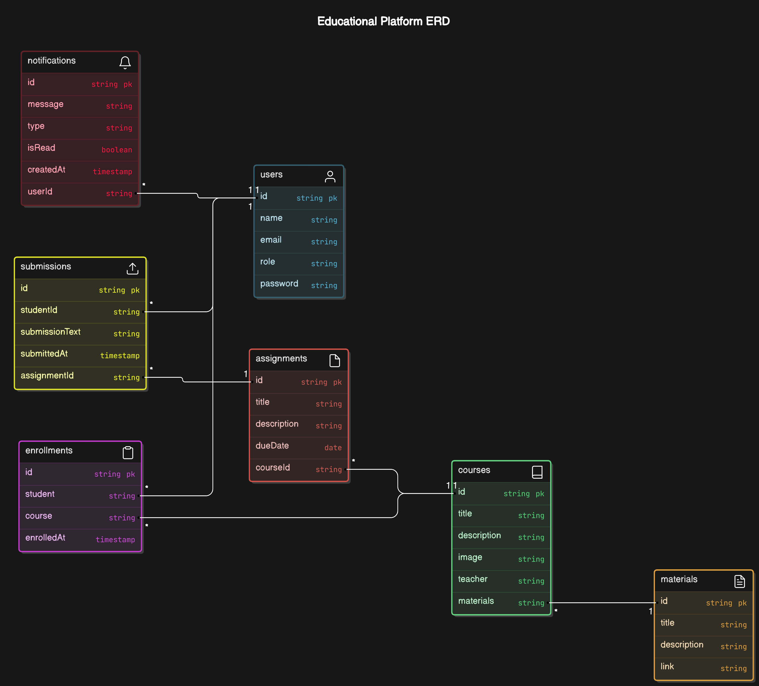

#### 9. Business Flow

The **E-Learning Platform** facilitates interaction between students and teachers for managing courses, assignments, and other educational resources. Below is the business flow for the project:

**1. User Registration and Login**

* **Actors**: Student, Teacher
* **Flow**:
  1. A user (student or teacher) visits the platform and registers by providing necessary details (name, email, password).
  2. Upon registration, the system validates the information, creates a new user record in the database, and assigns the user a role (either "student" or "teacher").
  3. The user can then log in using the registered email and password.
  4. After successful login, the user is redirected to the respective dashboard based on their role (students go to the course browsing section, teachers go to the course creation section).

**2. Profile Management**

* **Actors**: Student, Teacher
* **Flow**:
  1. Once logged in, the user can view and edit their profile (name, email, and password).
  2. Teachers can also update their bio, contact information, and profile picture.
  3. Students can view their enrolled courses, assignments, and notifications on their profile.

**3. Course Creation and Management (For Teachers)**

* **Actors**: Teacher
* **Flow**:
  1. After logging in, the teacher accesses the "Create Course" section.
  2. The teacher enters the course details (title, description, image, etc.) and uploads necessary materials (course materials, videos, etc.).
  3. The system creates a new course entry in the database and assigns the teacher as the course owner.
  4. Teachers can update or delete the course and manage enrolled students.

**4. Course Browsing and Enrolment (For Students)**

* **Actors**: Student
* **Flow**:
  1. Students can browse through the list of available courses from their dashboard.
  2. They can view details about each course (title, description, materials, assignments, etc.).
  3. Students can enrol in a course of interest. Once enrolled, they are granted access to the course materials and assignments.
  4. The system creates an enrolment record linking the student to the selected course.

**5. Upload and Access Course Materials**

* **Actors**: Teacher, Student
* **Flow**:
  1. **Teacher**: During course creation or management, the teacher can upload various types of materials (links) related to the course.
  2. **Student**: After enrolling, students can access and download course materials from their dashboard. They can also view resources uploaded by the teacher.

**6. Assignments**

* **Actors**: Teacher, Student
* **Flow**:
  1. **Teacher**: A teacher creates assignments for students, specifying the course, assignment title, description, and due date.
  2. **Student**: Students view assigned tasks on their dashboard. They submit their responses (text-based or file submissions) before the due date.

**7. Notifications**

* **Actors**: Student, Teacher
* **Flow**:
  1. **System**: The system sends notifications for various events like new course creation, new assignments, grade updates, or any messages from teachers.
  2. Notifications can be of different types, such as info, warning, error, or success, based on the event.
  3. **User**: The user receives these notifications on their profile/dashboard and can mark them as read once acknowledged.

**8. Messaging System**

* **Actors**: Student, Teacher
* **Flow**:
  1. **Teacher/Student**: Teachers and students can send private messages to each other regarding assignments, course details, or other queries.
  2. **System**: The system stores and manages messages and provides a chat interface for communication.
  3. Messages are timestamped and categorized into inbox and sent folders.
  4. Both users (sender and receiver) can view the message history.

**Summary of Key Steps:**

1. **User Registration**: Sign up and login process.
2. **Course Creation**: Teachers create and manage courses.
3. **Course Enrolment**: Students browse and enrol in courses.
4. **Material Access**: Teachers upload and students access course materials.
5. **Assignments**: Teachers create assignments, and students submit them.
6. **Notifications**: System sends alerts for important actions and updates.
7. **Messaging**: Allows teachers and students to communicate directly.

#### 10. Tech Stack Used

Mongo DB, React JS, Node JS, Express JS, (MERN Stack)

#### 11. Implementation

Registration Page:

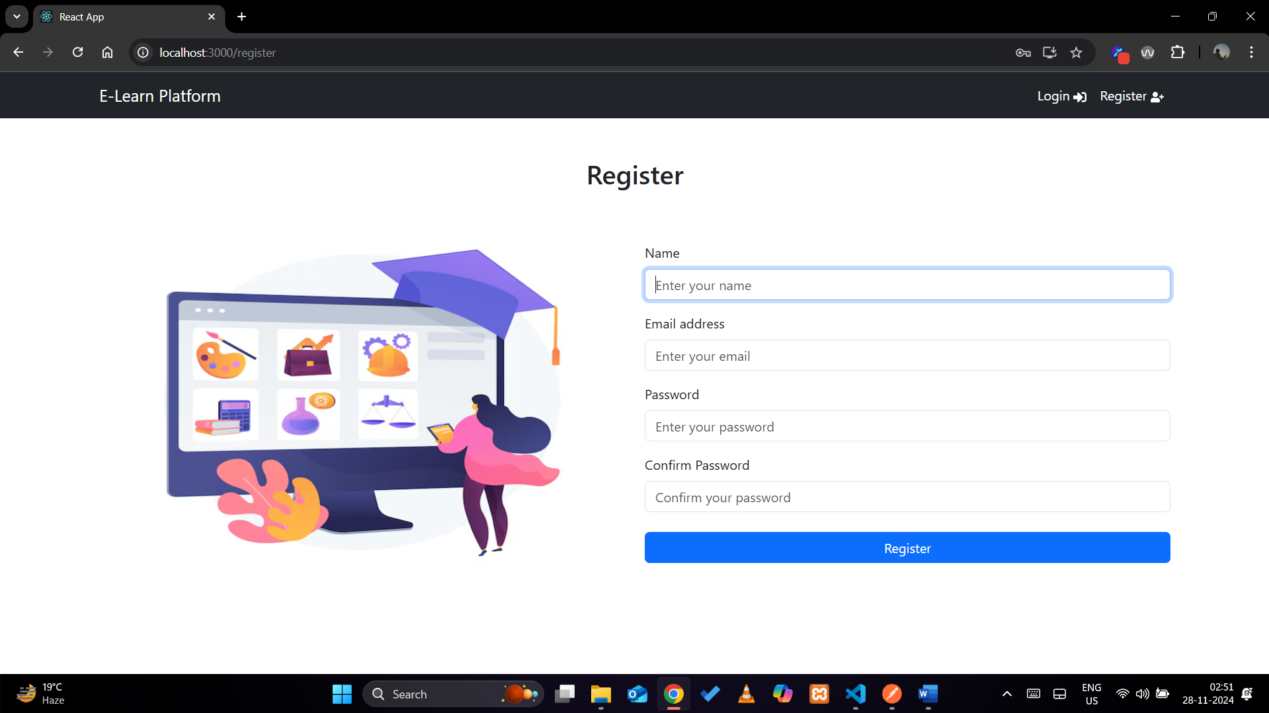

Login Page:

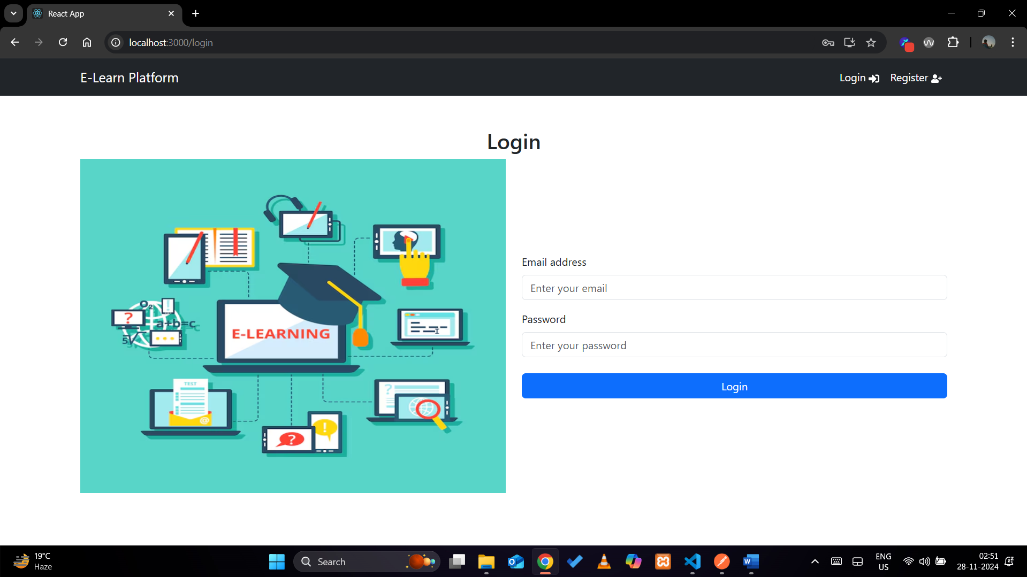

Teacher Dashboard:

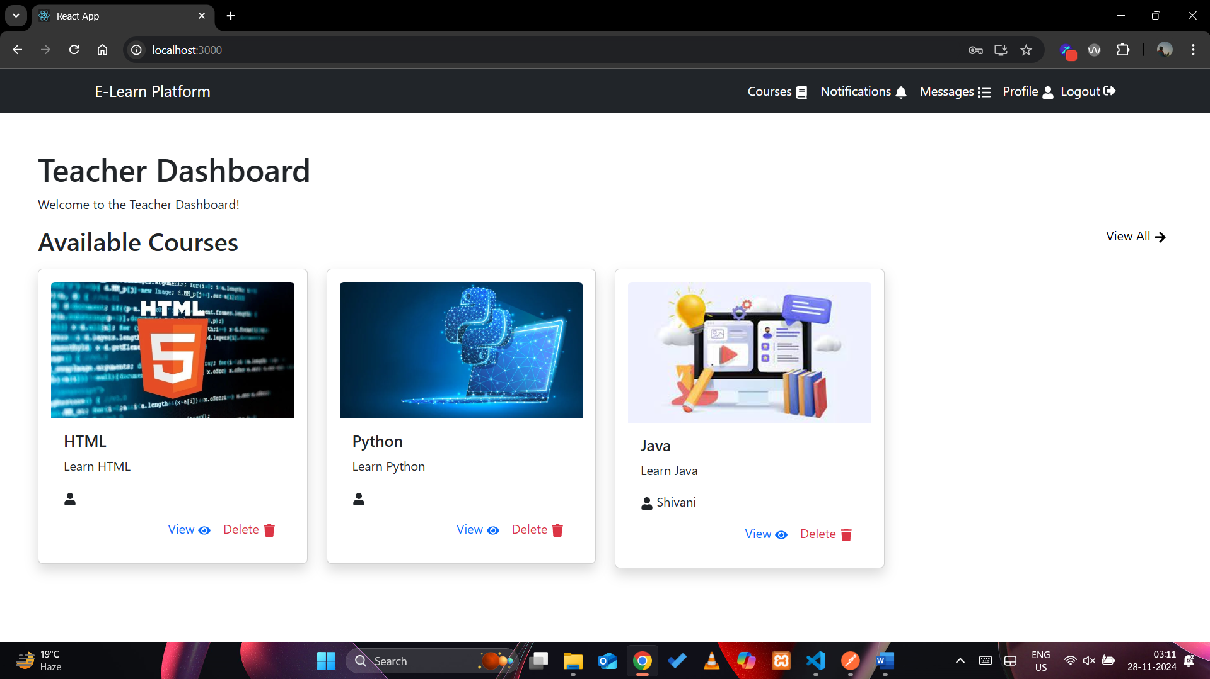

Courses Page:

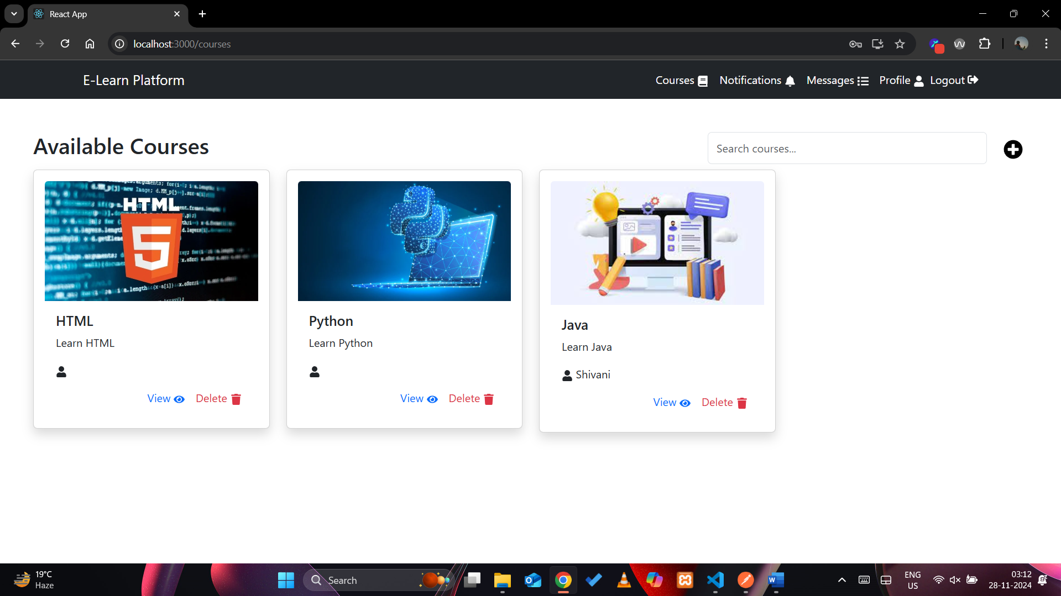

View Course:

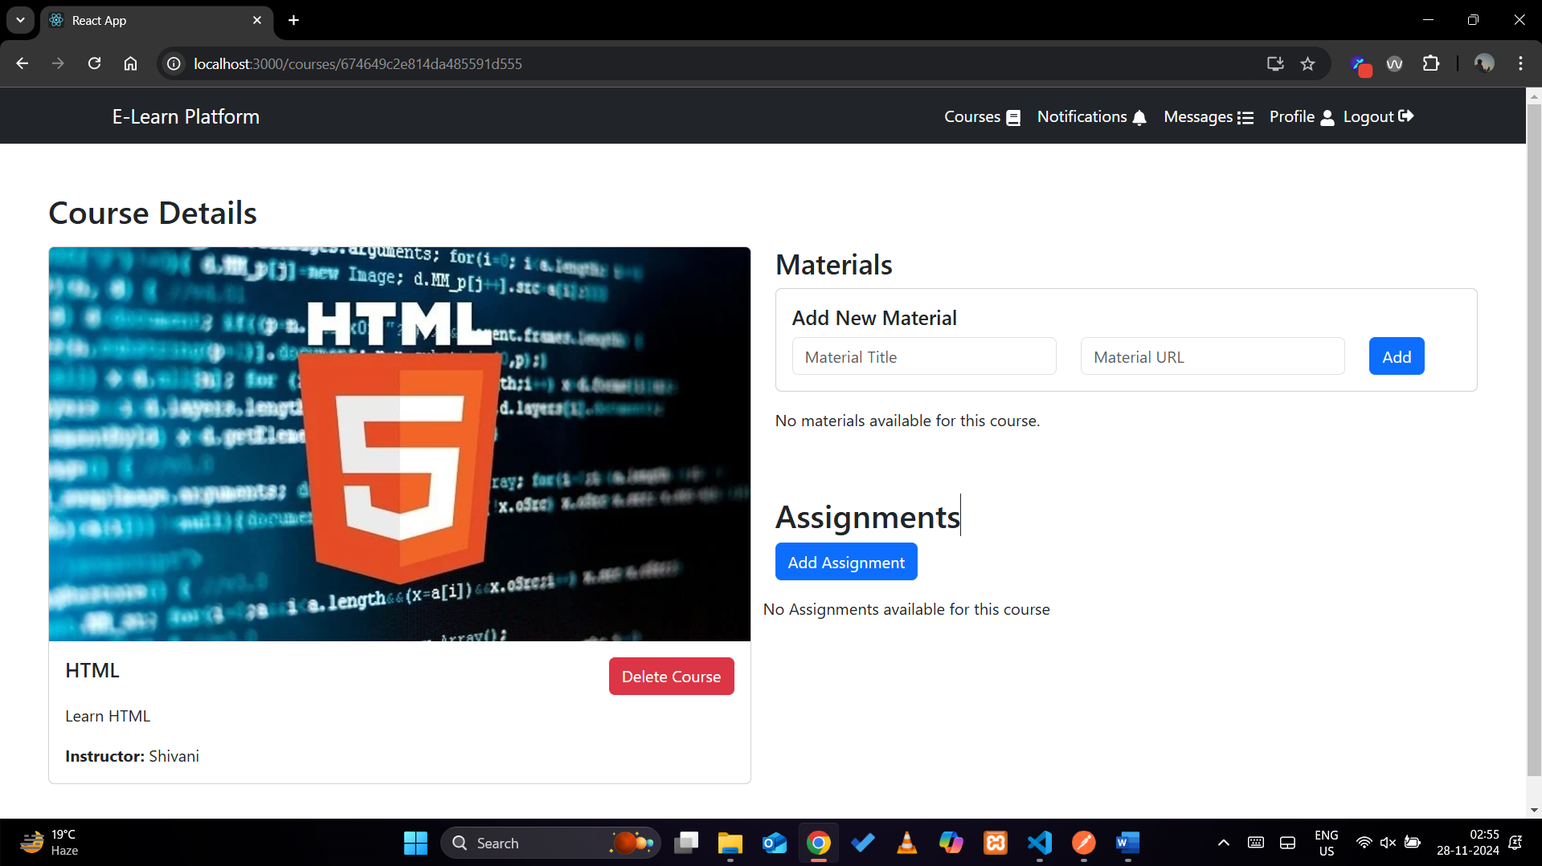

Create Course:

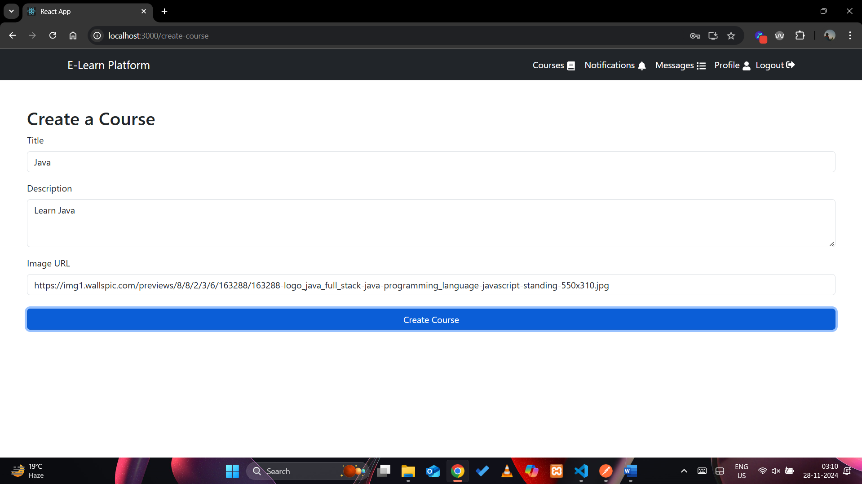

Delete Course:

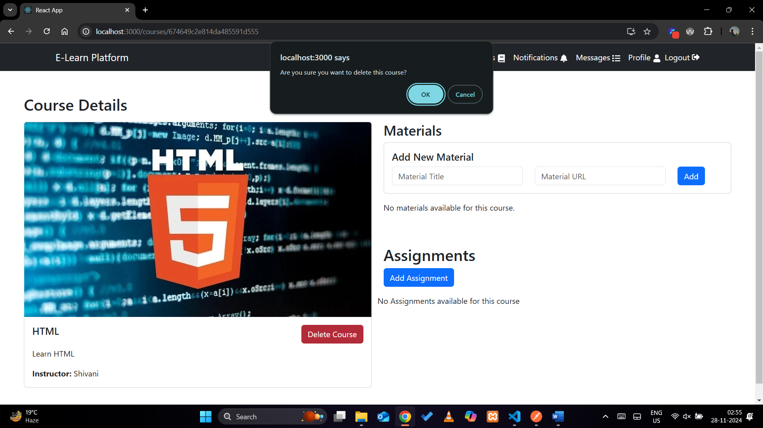

Add Material:

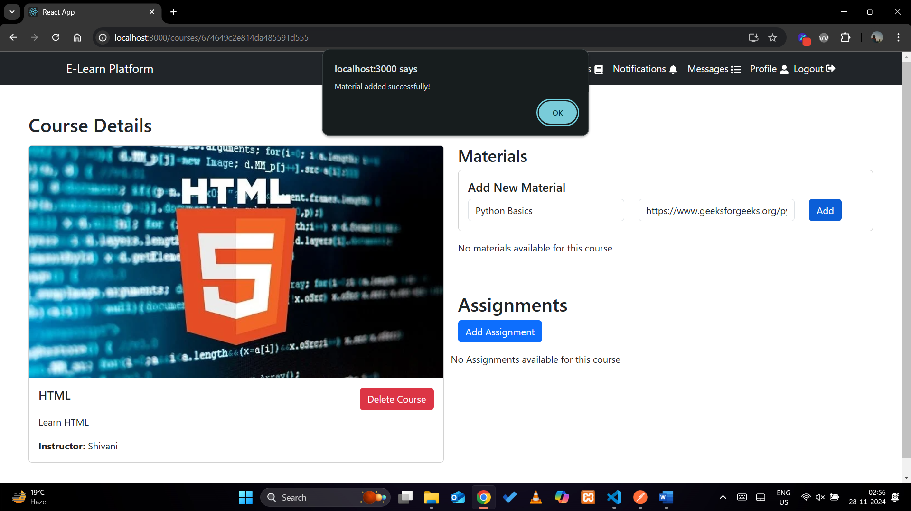

Delete Material:

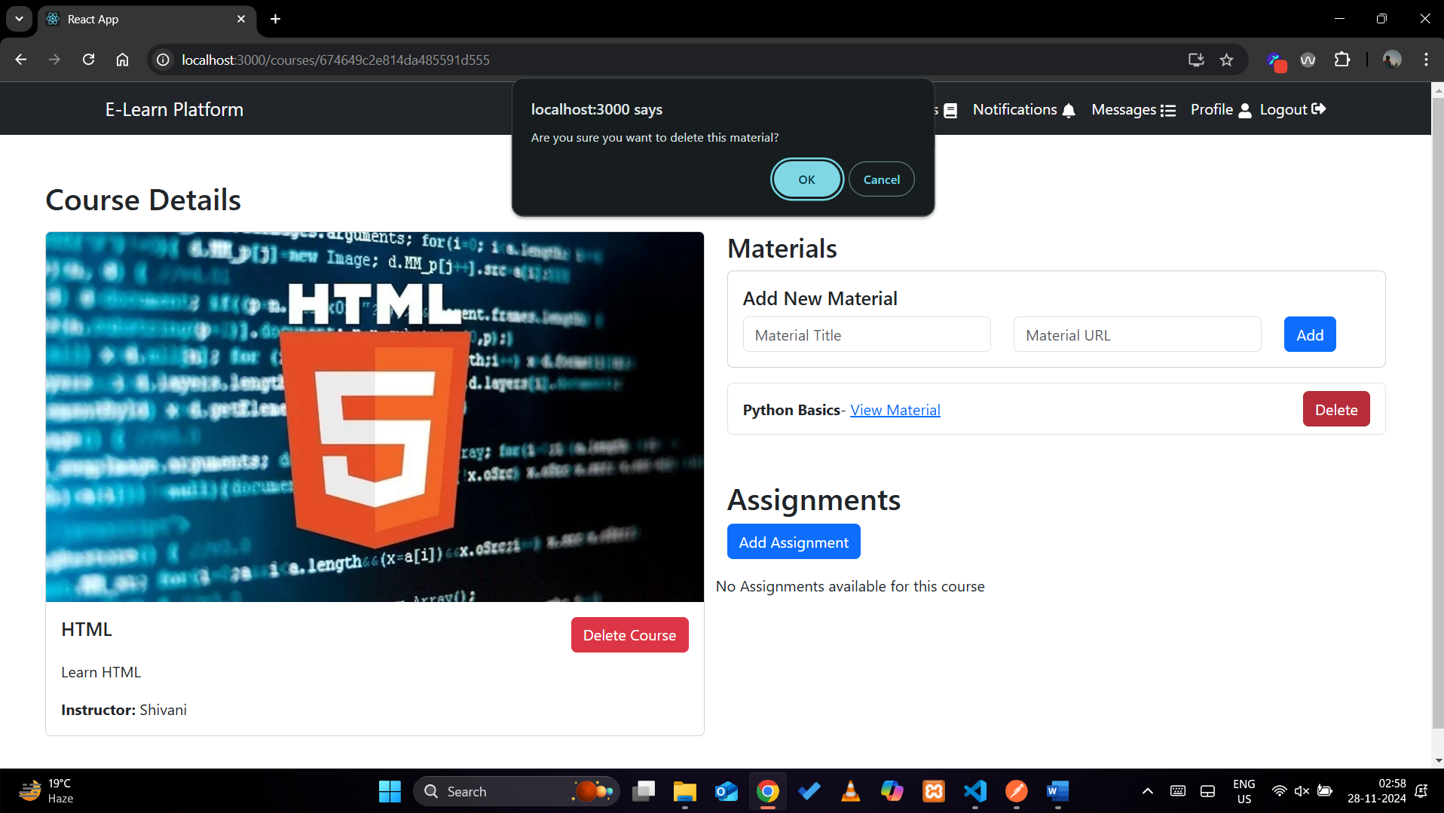

Add Assignment:

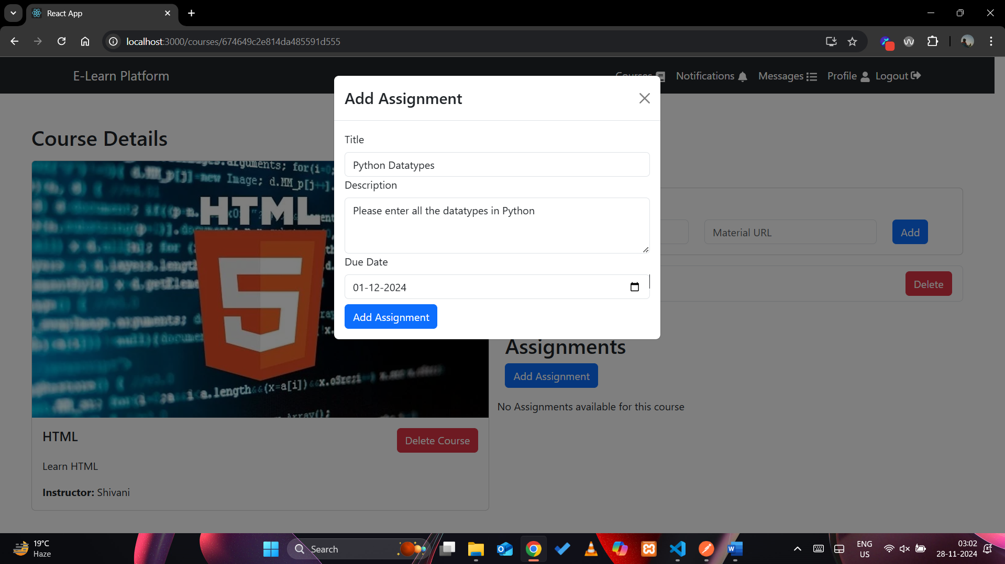

Delete Assignment:

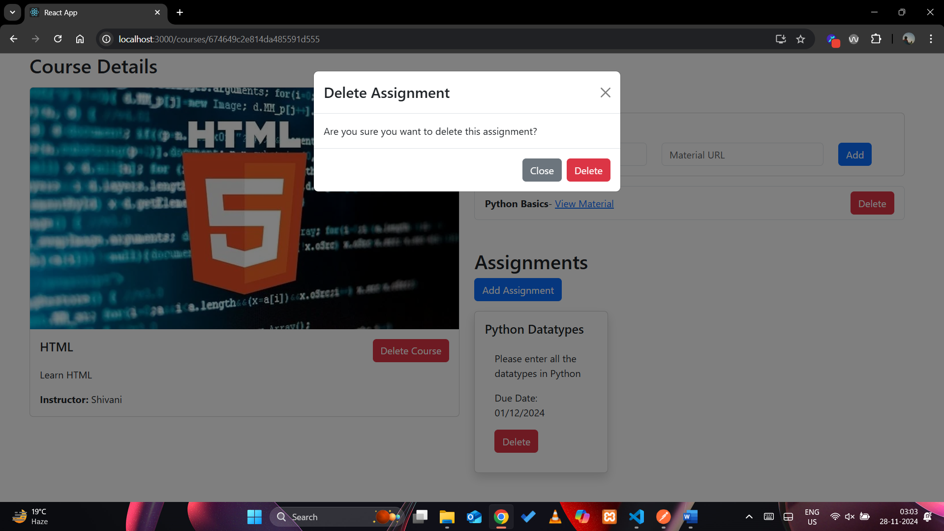

Student Dashboard:

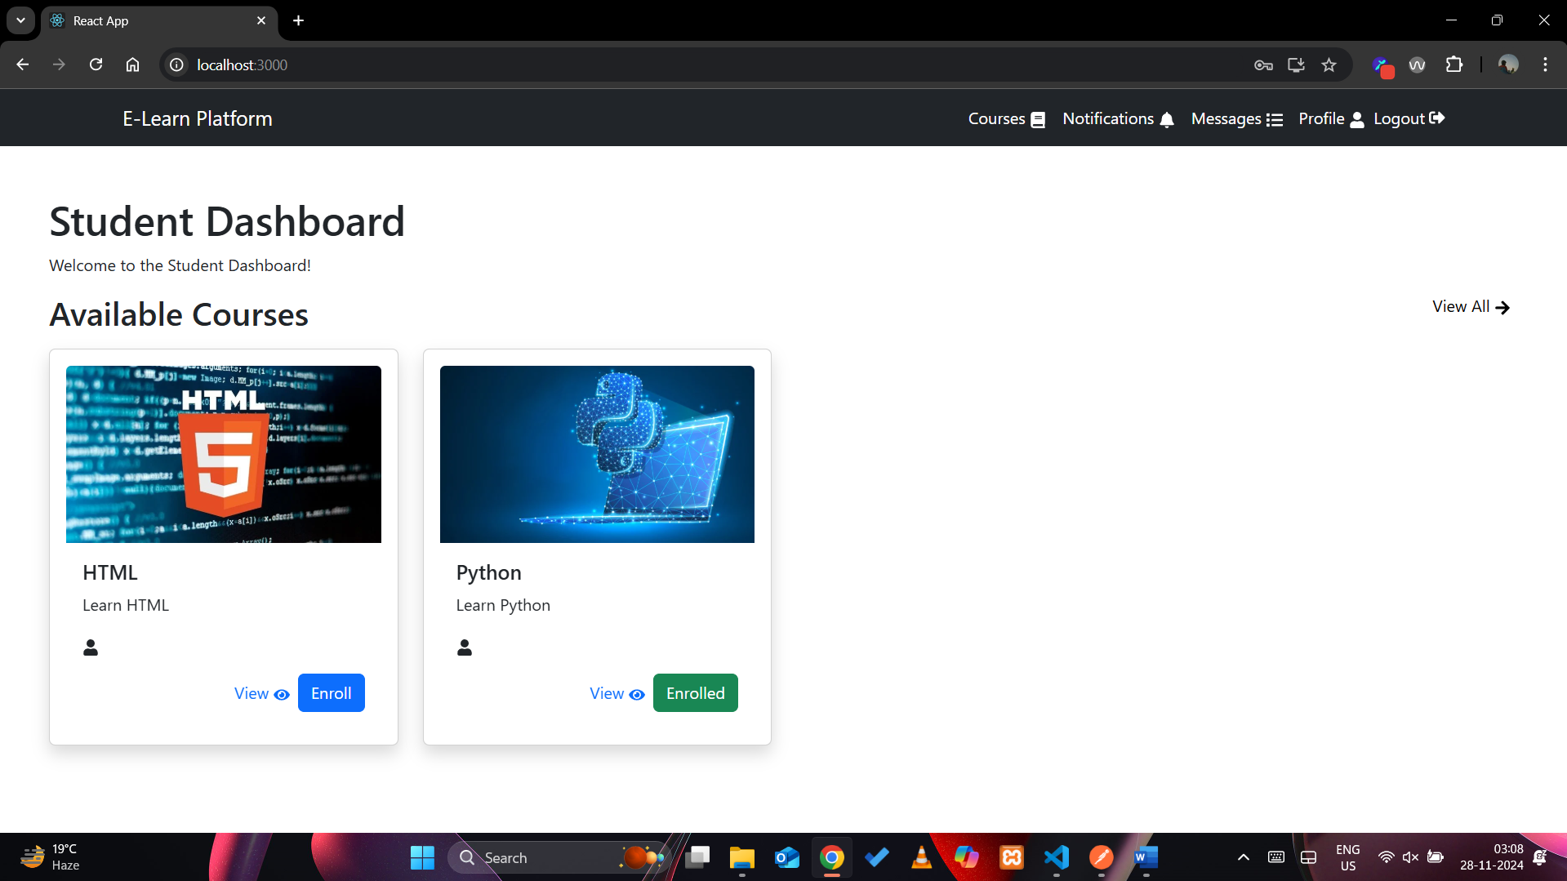

Enroll a Course:

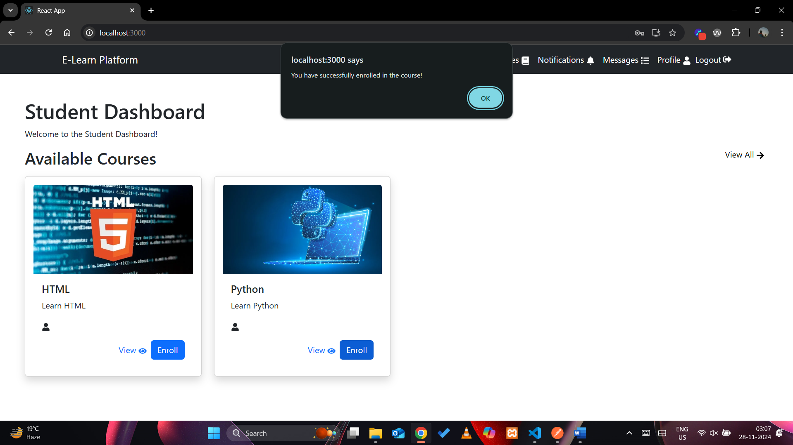

Notifications:

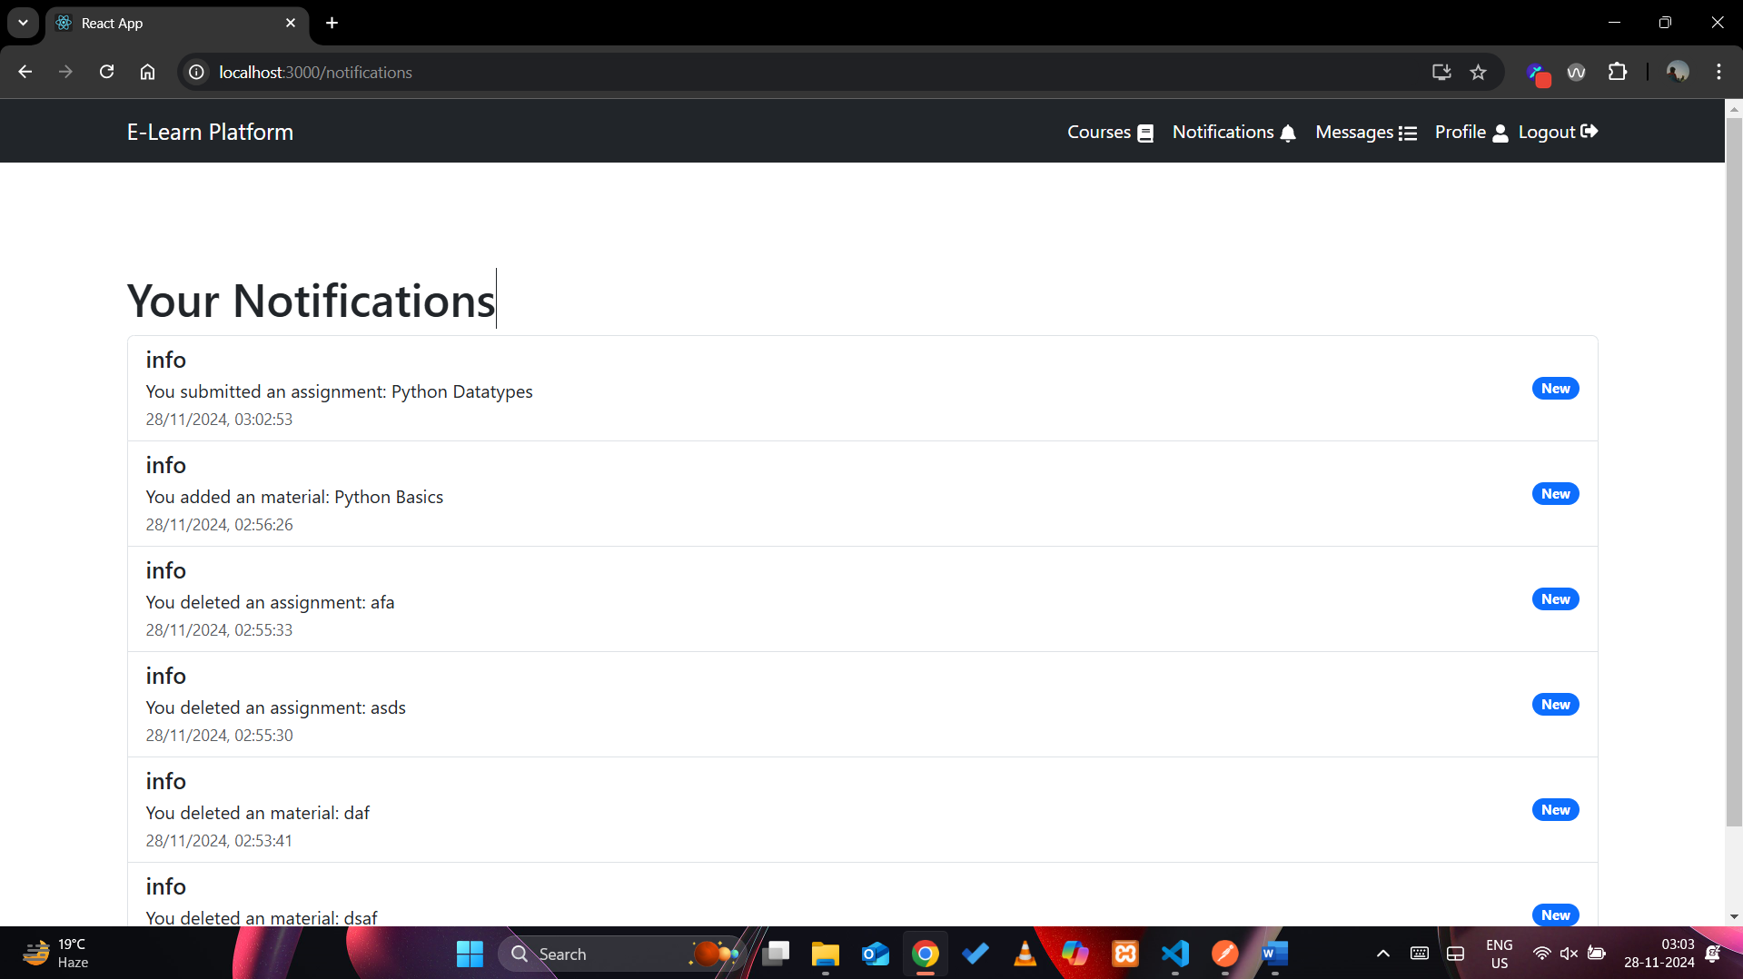

Messages:

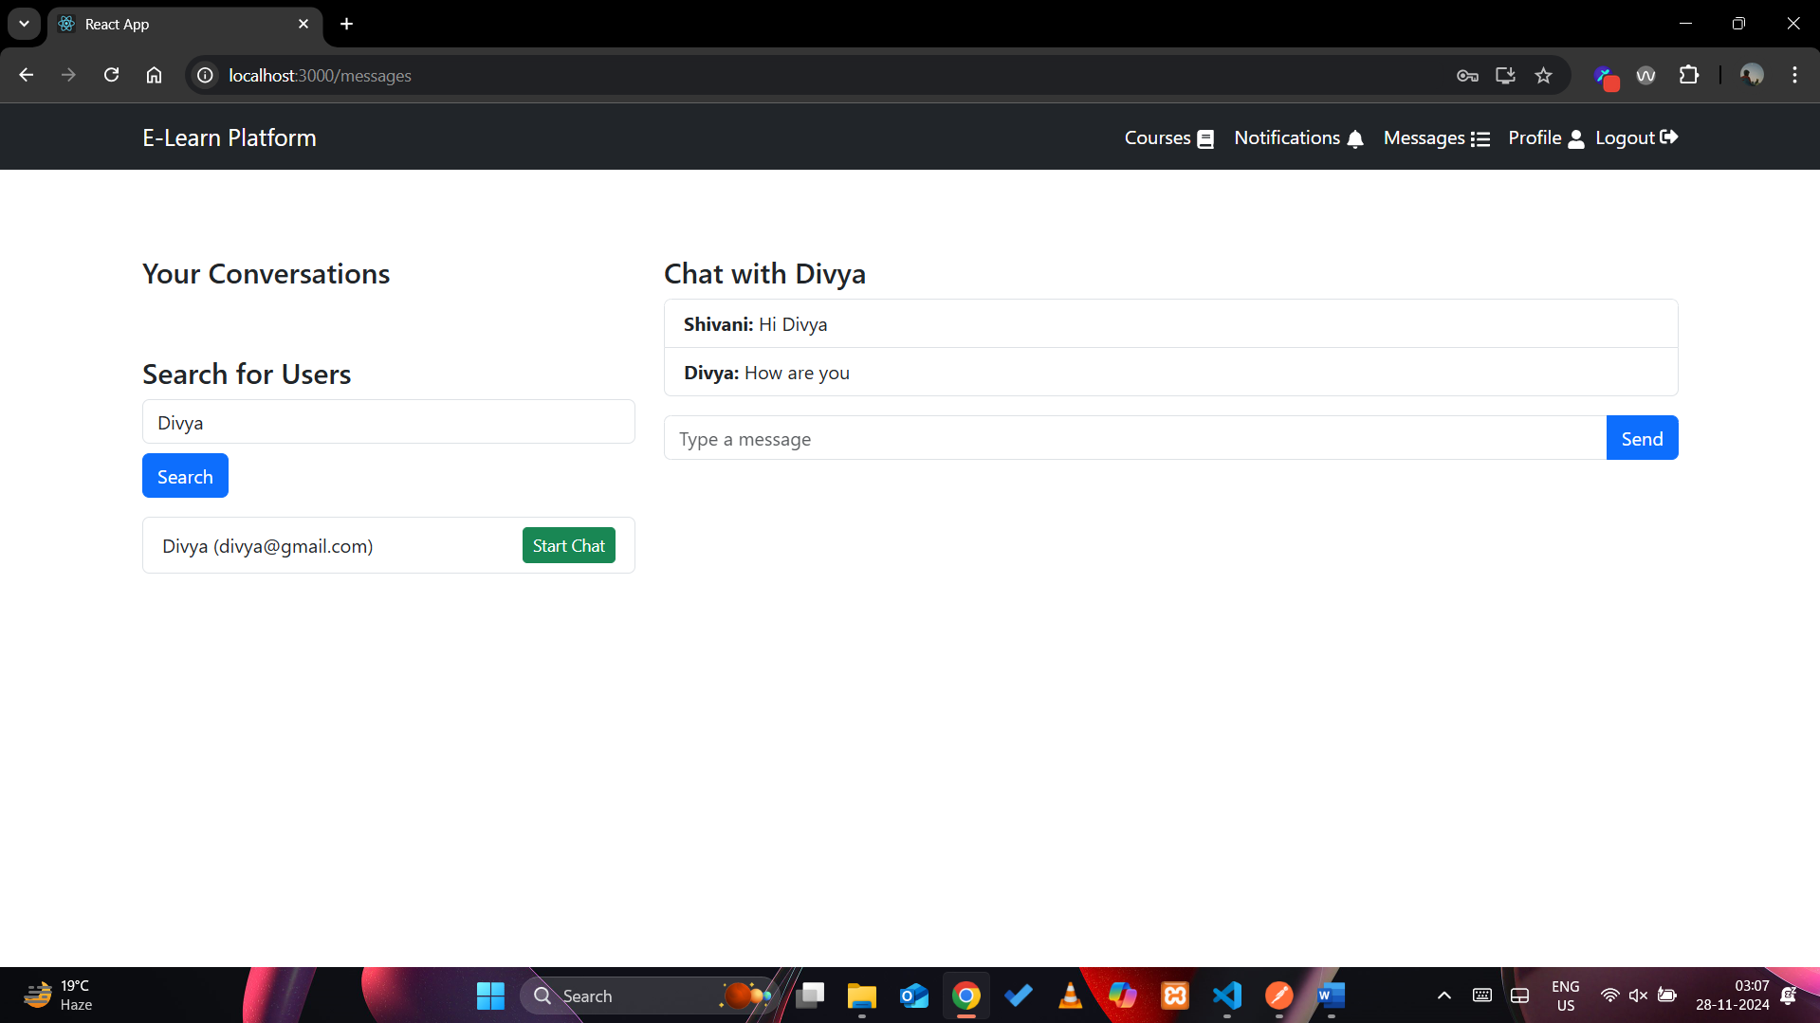

View Profile:

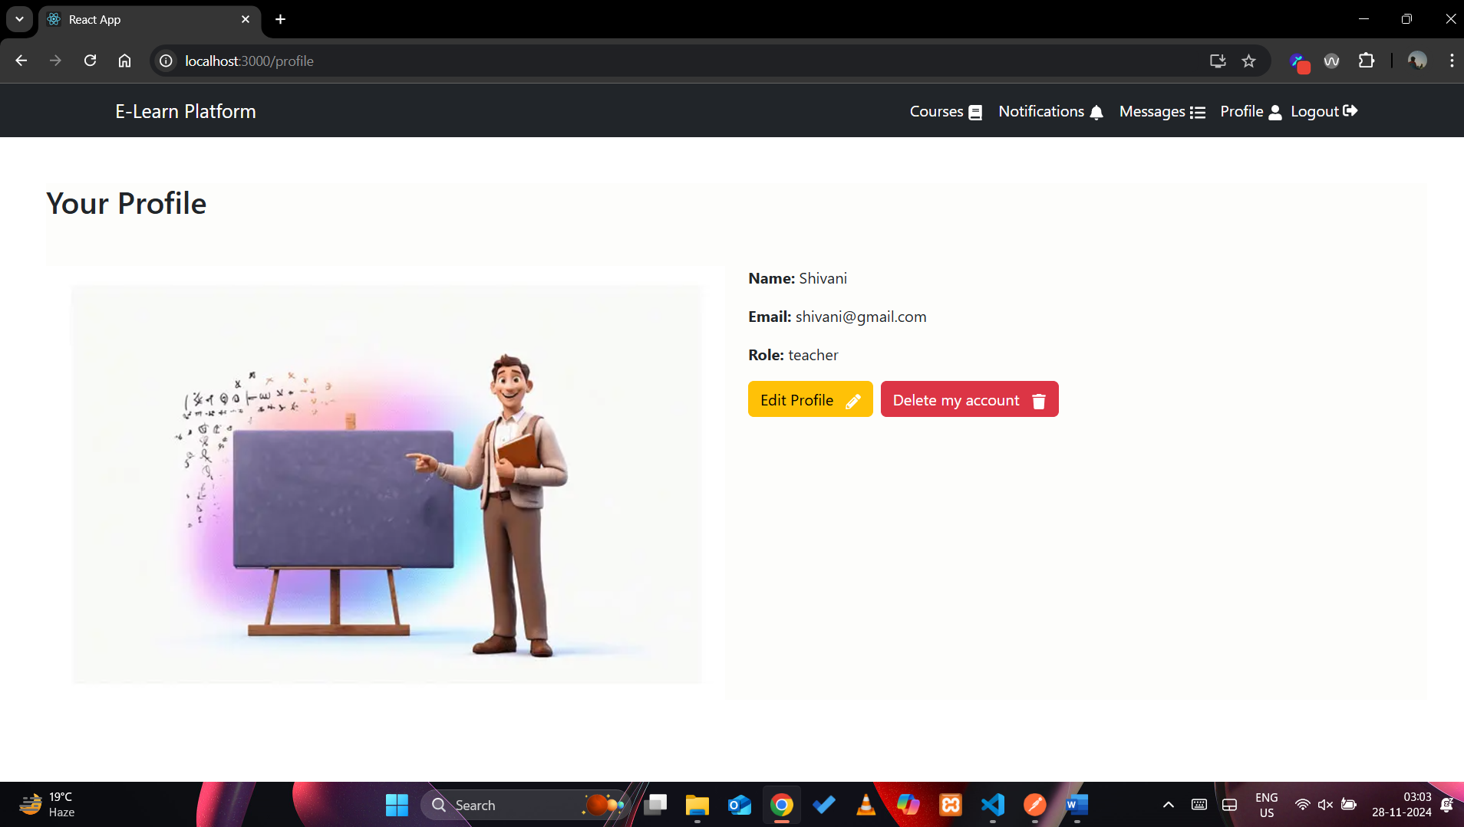

Edit Profile:

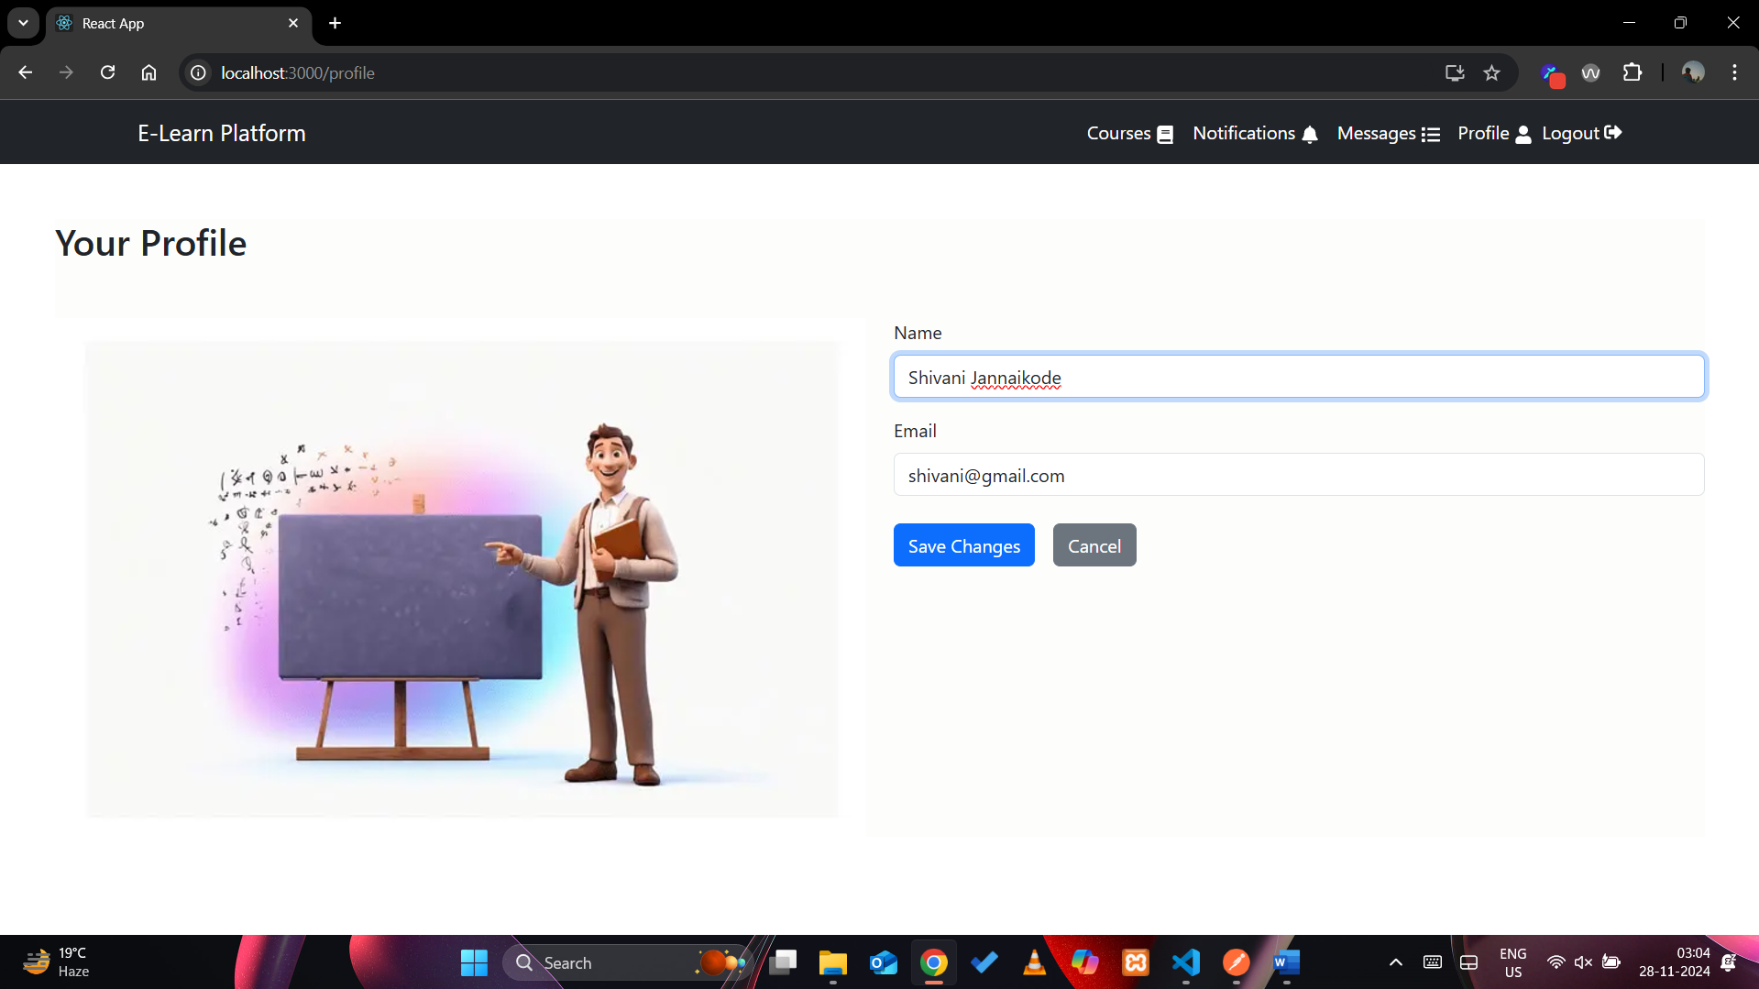

Delete Profile:

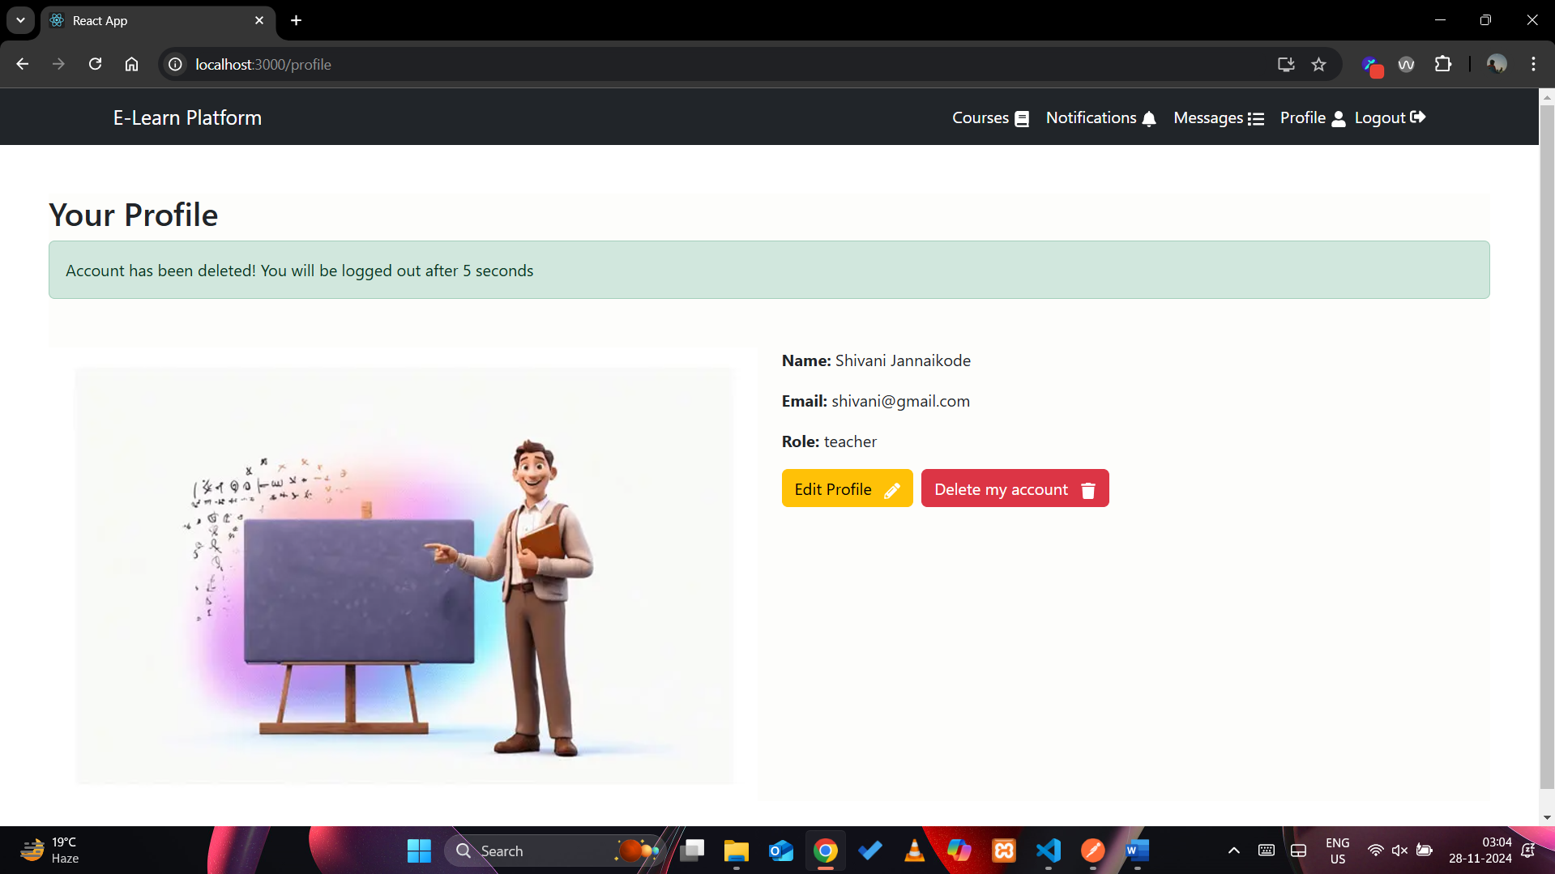

#### 12. Conclusion

The **E-Learning Platform** project is a comprehensive, user-friendly system designed to facilitate seamless interaction between students and teachers in an online education environment. The platform serves to enhance the learning experience by providing a range of features, including course creation and management, course browsing and enrollment, material sharing, assignment submission and grading, as well as notifications and messaging for efficient communication.